**Spencer Gifts – OMS**

**Photo Submission**

**Business Flow Document**

**

Prepared by : Dilip Ramakrishnan

Reviewed by : Sarvani Josyam

Date Submitted : 07/07/2021

Version : 0.1

Last revised date : 07/072021

**Revision History**

This document is being submitted to **Spencer Gifts** by **WinWire Technologies, Inc**. This document and any supporting appendices submitted with it are confidential and intended solely for the use of the business users and IT team working at **Spencer Gifts**.

**Change Record**

|  |  |  |  |
| --- | --- | --- | --- |
| **Date** | **Author** | **Version** | **Change reference** |
| 07/07/2021 | Dilip Ramakrishnan | 0.1 | Initial draft. |
|  |  |  |  |
|  |  |  |  |
|  |  |  |  |

**Reviewers**

|  |  |  |  |
| --- | --- | --- | --- |
| **Name** | **Version approved** | | **Date** |
| Sarvani Josyam | 0.1 |  | |
|  |  |  | |
|  |  |  | |

Table of Contents

1.1 Role for Photo Submission / Login ---------------------------------------------------------4

1.1.1 Navigating to the respective page after login according to role ---------------4

1.2 DSM User ---------------------------------------------------------------------------------------- 5

1.2.1 DSM User (Resubmit) ---------------------------------------------------------------------- 6

1.3 Zone Manager ------------------------------------------------------------------------------------- 7

1.4 HO Reviewer ---------------------------------------------------------------------------------- 8 -10

1.5 Admin -------------------------------------------------------------------------------------------11-14

## Role for Photo Submission / Login Page

### Navigating to the respective page after login according to role.

1. We have 3 major roles in Photo Submission.

* DSM User
* Zone Manager
* HO Reviewer

1. **DSM User** can Upload images, comment in Submitter Comment field, and submit for desired GOP Set.
2. **Zone Manager** can Approve/Reject using reject checkbox or edit a photo put in place by the DSM.
3. **HO Reviewer** can search any desired GOP Set using the filter options and can click on Updates Needed or Visually Reviewed accordingly.
4. Once the user enters the credential accordingly user will navigate to the respective page.
5. For ex: If user enters DSMUser / ZoneManager / HoReviewer as Username with a valid password then user will be redirected to respective page.

## DSM User:

1. GOP Set Selector will be populated from Identity server.
2. Submitter can select the desired GOP set and Season from dropdown.
3. All available slots for the selected store will be displayed.
4. Submitter can then upload images for desired stores and desired season enter comments(optional) in the DSM “Submitter Comments” field for the Not Submitted GOP Set.

1. Submitter can either save the process by clicking on Save and return later and submit or can directly Submit once all the desired changes are made.
2. Once the Submitter clicks on Submit GOP Set the changes for that GOP Set will be saved to the database and all the fields will be in disabled mode for the Submitter for that GOP Set until the Zone Manager Rejects.

### DSM User (Resubmit)

1. Once the Zone manager rejects the GOP Set the rejected Slot image will consist of a RED color border indicating it as a rejected slot and remaining slot will consist of GREEN color border indicating as approved and in addition to that Approver comment text box with the Approver comment (if provided) will be visible in a read-only format to the submitter.
2. The submitter then again must update the rejected slot with a new image or can checkmark “Photo Not Applicable” checkbox according to their requirement.

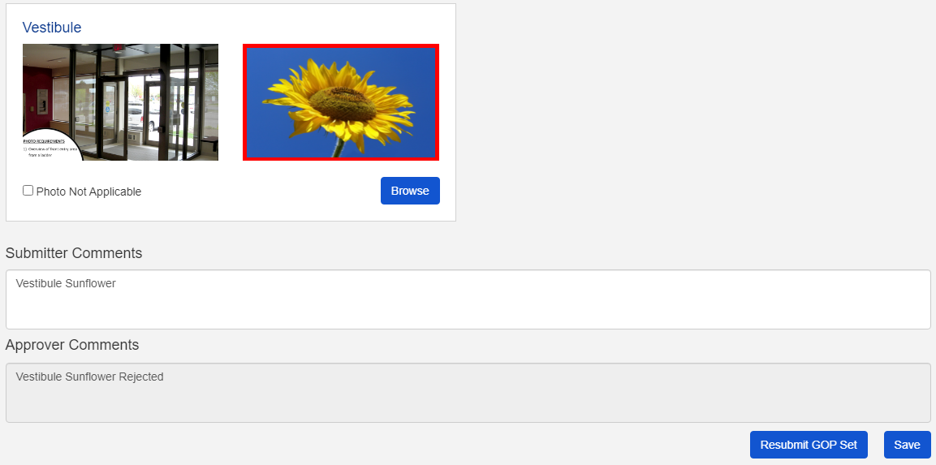

1. Once the submitter has made necessary changes can click on Resubmit GOP set to submit the GOP Set again.
2. If the Photo Not Applicable checkbox is checked the Browse button will be disabled until it is again unchecked.

## Zone Manager:

1. Zone manager can select the desired GOP set and Season from dropdown.
2. All available slots for the selected store will be displayed.
3. Zone manager can Approve /Reject the GOP Set or can also upload images to the required slot if necessary and check or uncheck the photo not applicable checkbox. The Submitter Comments will be in read-only format for the Zone Manager.
4. Zone Manager can make changes and click on Save to save and the return later to approve/ reject.
5. If the Photo Not Applicable checkbox is checked the Browse button will be disabled until it is again unchecked.

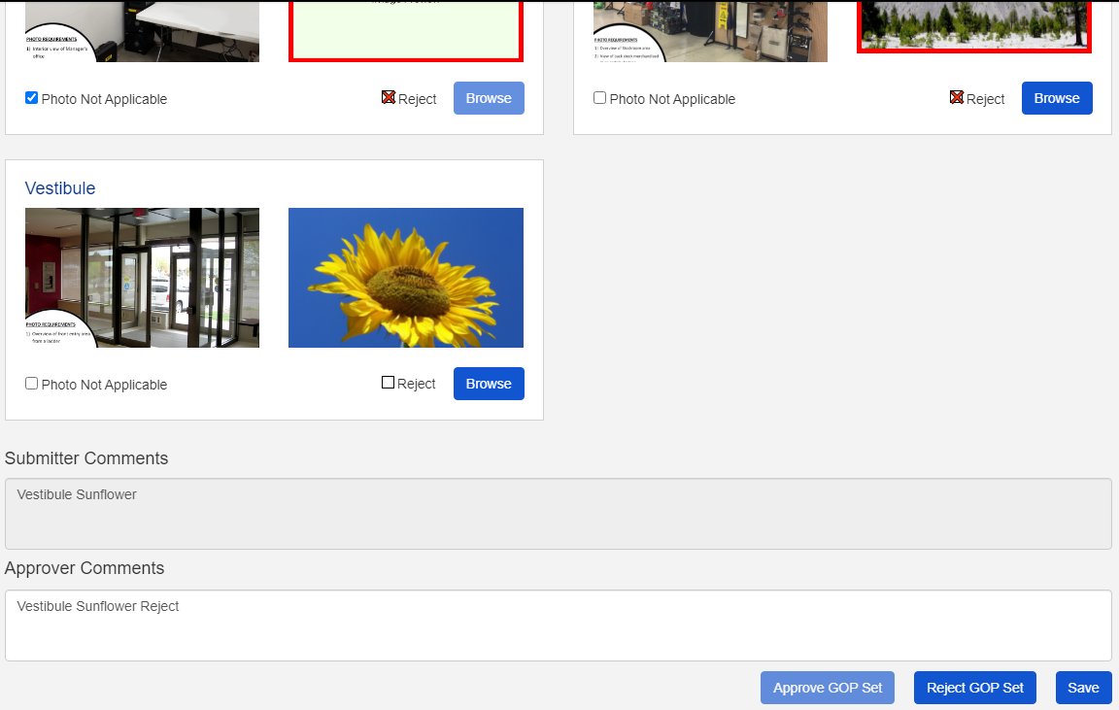

1. Zone Manager can click on Reject or Photo Not Applicable and provide Comments in the Approver Comment field (Optional) and then clicks on Reject GOP Set to Reject the GOP Set.
2. Zone Manager can else directly click on Approve GOP Set to approve the complete GOP Set.
3. Once the Zone Manager approves/ rejects the GOP Set all the field will be disabled for the Zone Manager.

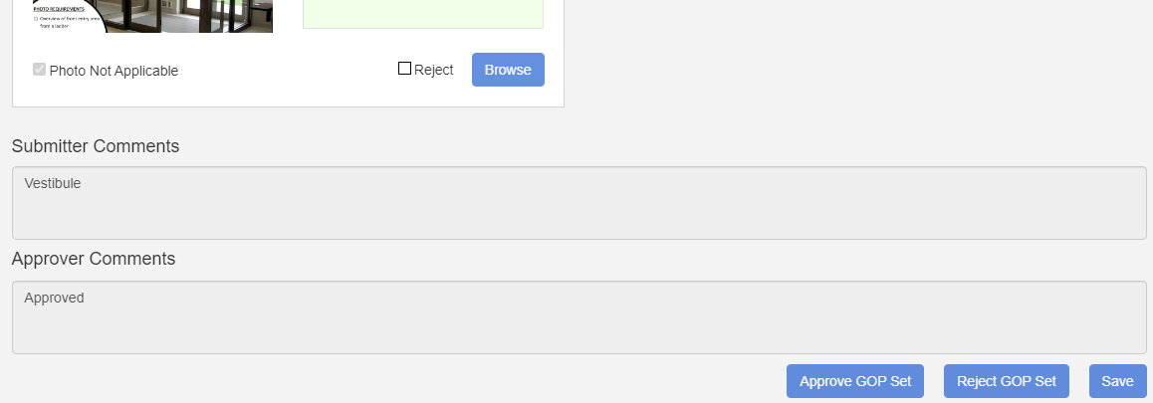

## HO Reviewer:

1. HO Reviewer can search desired GOP Set using filter.

1. HO Reviewer can search by selecting GOP Set Status that have been Submitted, Approved, Rejected, Updates Needed or Visually Reviewed and Season along with either GOP Set Selector or Photo Type Selector then the selected GOP Set will be displayed according to the filter selection.

1. HO Reviewer can also search using Sales Plan and the GOP Set Selector which has the specified filter amount will be populated in the GOP Set Selector.

1. HO Reviewer after searching for desired GOP Set can then either click Updates Needed or Visually Reviewed for only the “APPROVED” GOP Set or provide with the comments in HO Reviewer comments field (Optional).

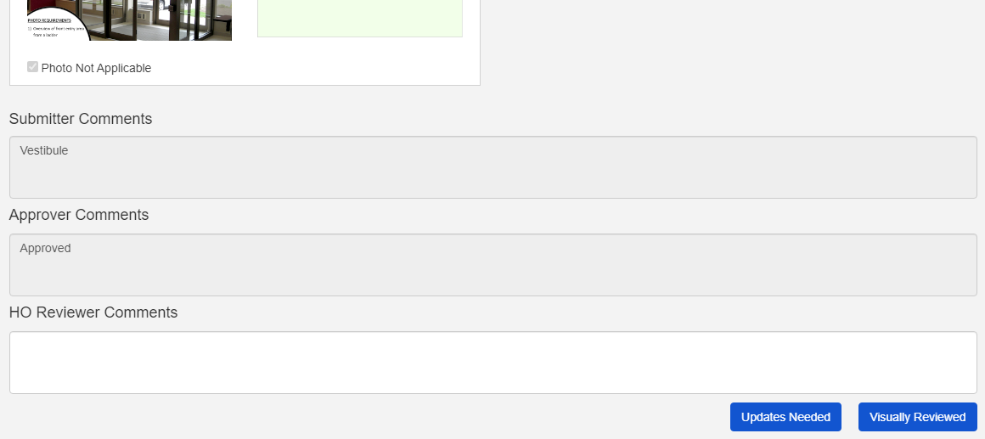

1. GOP Set Status such as Submitted, Rejected, Updates Needed or Visually Reviewed can only be searched and will be visible in read-only mode for the HO Reviewer.

(Image for Reference**:** Rejected Slot).

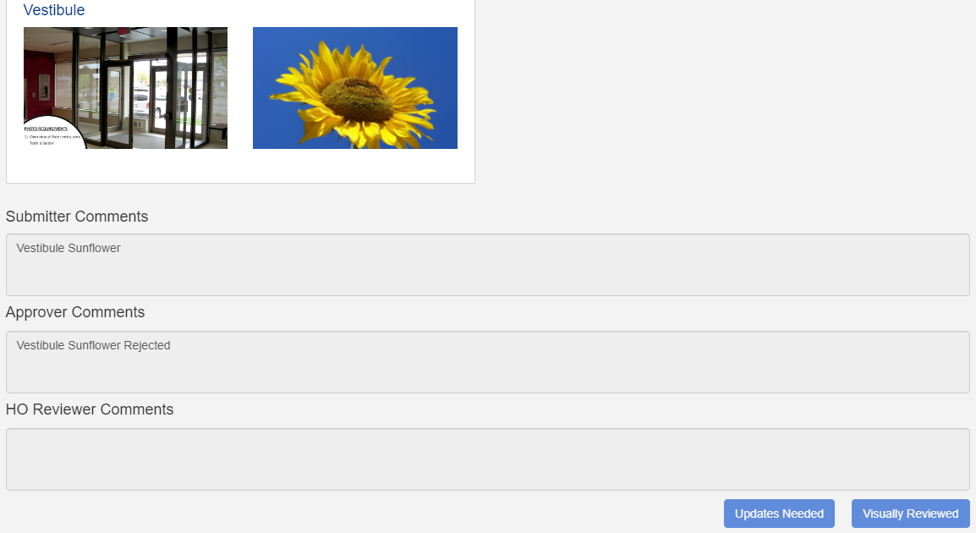

1. Once HO Reviewer clicks on Update Needed the GOP Set then will again have the status as Updates Needed for the DSM User and Zone Manager for future changes /modification to be done by either the Submitter or Zone Manager.
2. Once HO Reviewer if clicks on Visually Reviewed will then change the status into Visually Reviewed and all the fields for image upload including text box will be in read-only (Disabled Mode) for all the three roles: DSM User, Zone Manager and HO Reviewer.

## Admin:

1. Admin Screen can be used to configure slots for all or for individual store by selecting store from dropdown. All available slots will be displayed for both the Season.

1. Once Selected and saved will be displayed accordingly. Can be edited whenever needed.

1. **Slot**: Another admin tab can be selected from the admin dropdown which is present in menu bar. Which displays all the slot along with the images which can be uploaded.

1. Add Slot is used to Add new slot by giving the slot name. Multiple slot name can be provided and once save all the slot will be available along the List of slots

1. Edit Slot icon can be used to edit the name of already present slot.

1. Delete icon can be used to delete the slot which are not needed.
2. Drag icon can be used to drag and drop the Slots anywhere and save the slot which will save the slot in order.